

Project Report
Weather-related disease prediction
Bachelor of Computer Applications
Semester II
Introduction to Data Science
By
Shivam patel
2411021240016

Department of Computer Applications
Alliance University
ChandapuraAnekal Main Road, Anekal
Bengaluru562106

April 2025

Introduction

Weather plays an important role in our health. When there are changes in temperature, rainfall, humidity, or wind, it can lead to the spread of many diseases. For example, diseases like dengue, malaria, and flu are often seen more during certain weather conditions. These are called weather-related diseases.
The main goal of this project is to predict the chances of a disease happening based on the weather. If we can guess early when and where a disease might spread, it will help people and health workers take action on time and stay safe.
For this project, we are using a dataset that has information about weather (like temperature, rain, humidity, wind) and the diseases reported during that time. The dataset has more than 5000 rows, which gives us enough information to study and find patterns.
We will use data analysis methods like univariate, bivariate, and multivariate analysis to study the data. We will also try to build a simple machine learning model that can help in predicting diseases based on weather data.
This project shows how data and technology can help in the field of health and can make a big difference in saving lives.

import pandas as pd
import seaborn as sns
import matplotlib.pyplot as plt
data = pd.read_csv(r"D:\Download\archive (31)\Weather-related disease prediction.csv")
print(data.head())
Age Gender Temperature (C) Humidity Wind Speed (km/h) nausea \
0 4 1 25.826 0.740000 8.289000 1
1 55 0 21.628 0.600000 15.236000 0
2 45 0 13.800 0.817083 4.291992 0
3 6 0 37.254 0.610000 18.009000 1
4 70 0 18.162 0.870000 17.916000 0
joint_pain abdominal_pain high_fever chills ... facial_pain \
0 0 0 0 0 ... 0
1 0 0 0 1 ... 0
2 0 0 0 0 ... 0
3 0 0 1 0 ... 0
4 0 0 0 0 ... 1
shortness_of_breath reduced_smell_and_taste skin_irritation itchiness \
0 1 0 0 0
1 0 0 0 0
2 0 0 0 0
3 0 0 0 0
4 0 0 0 0
throbbing_headache confusion back_pain knee_ache prognosis
0 0 0 0 0 Heart Attack
1 0 0 0 0 Influenza
2 0 0 0 0 Influenza
3 0 0 0 0 Dengue
4 0 0 0 0 Sinusitis
[5 rows x 51 columns]
data.tail()
Age Gender Temperature (C) Humidity Wind Speed (km/h) nausea \
5195 91 1 21.714000 0.870000 5.450000 0
5196 83 0 10.491000 0.920000 9.165000 0
5197 77 0 19.942824 0.744583 9.305129 0
5198 84 0 20.069000 0.850000 17.971000 0
5199 100 1 38.021000 0.750000 18.300000 0
joint_pain abdominal_pain high_fever chills ... facial_pain \
5195 1 0 0 0 ... 0
5196 0 0 0 0 ... 0
5197 0 0 0 0 ... 0
5198 0 1 0 0 ... 0
5199 0 0 0 0 ... 0
shortness_of_breath reduced_smell_and_taste skin_irritation \
5195 0 0 0
5196 0 0 0
5197 0 0 0
5198 1 0 0
5199 0 0 1
itchiness throbbing_headache confusion back_pain knee_ache \
5195 0 0 0 0 1
5196 0 0 0 0 0
5197 0 0 0 0 0
5198 0 0 0 0 0
5199 1 0 0 0 0
prognosis
5195 Arthritis
5196 Stroke
5197 Influenza
5198 Heart Attack
5199 Eczema
[5 rows x 51 columns]
#UNIVARIATE
#HISTOGRAM
sns.histplot(data['Age'])
<Axes: xlabel='Age', ylabel='Count'>
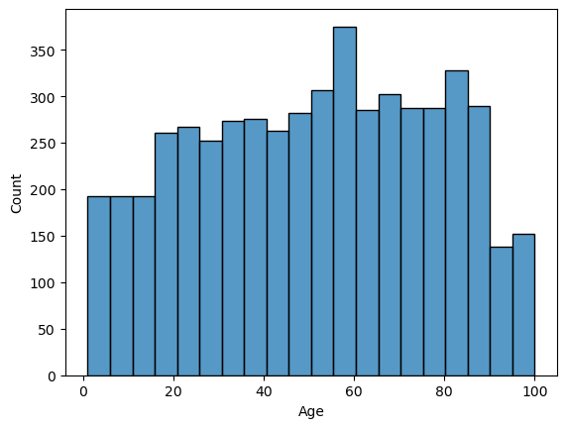
#BAR CHART
sns.countplot(x=data['Gender'])
<Axes: xlabel='Gender', ylabel='count'>
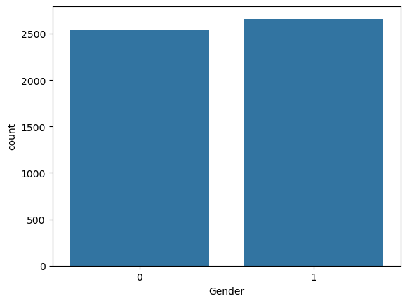
#PIE CHART
x = data['Gender'].value_counts()
plt.pie(x.values, labels=x.index, autopct='%1.1f%%')
plt.show()
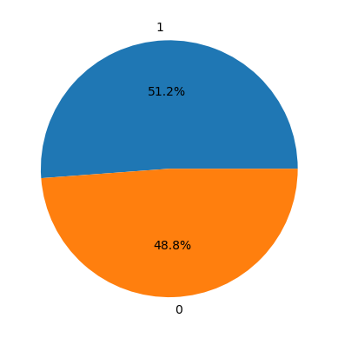
#BIVARIATE ANALYSIS
#Categorical v/s Numerical
import matplotlib.pyplot as plt
import seaborn as sns
plt.figure(figsize=(15, 5))
sns.barplot(x=data['Gender'], y=data['prognosis'])
plt.xticks(rotation=90)
plt.title('Gender vs Prognosis')
plt.xlabel('Gender')
plt.ylabel('Average Prognosis')
plt.show()
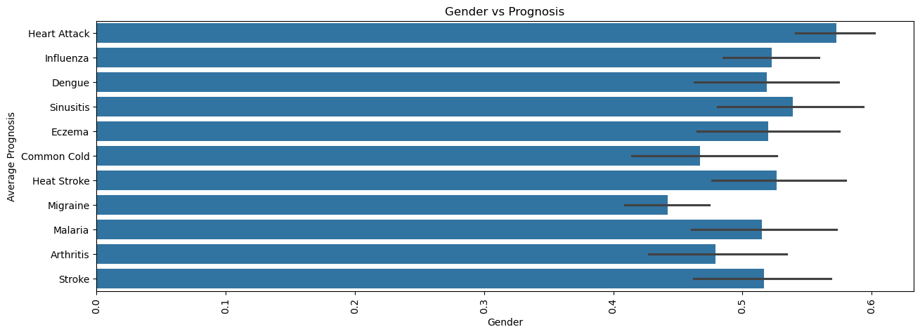
#numerical vs numerical
sns.scatterplot(x=data['nausea'],y=data['joint_pain'])
<Axes: xlabel='nausea', ylabel='joint_pain'>
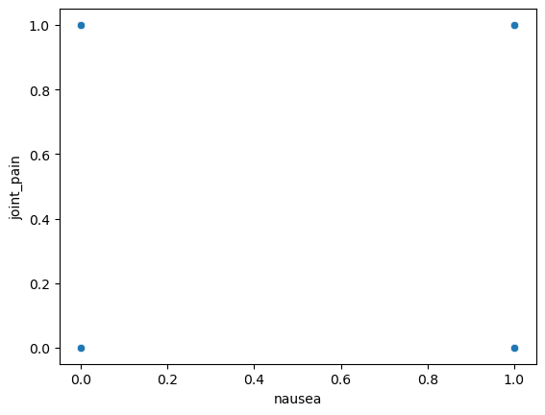
#Categorical v/s Categorical
plt.figure(figsize=(15, 5))
sns.countplot(x='prognosis', hue='high_fever', data=data)
plt.xticks(rotation=90)
plt.title('Prognosis vs High Fever')
plt.xlabel('Prognosis')
plt.ylabel('Count')
plt.legend(title='High Fever (0 = No, 1 = Yes)')
plt.show()
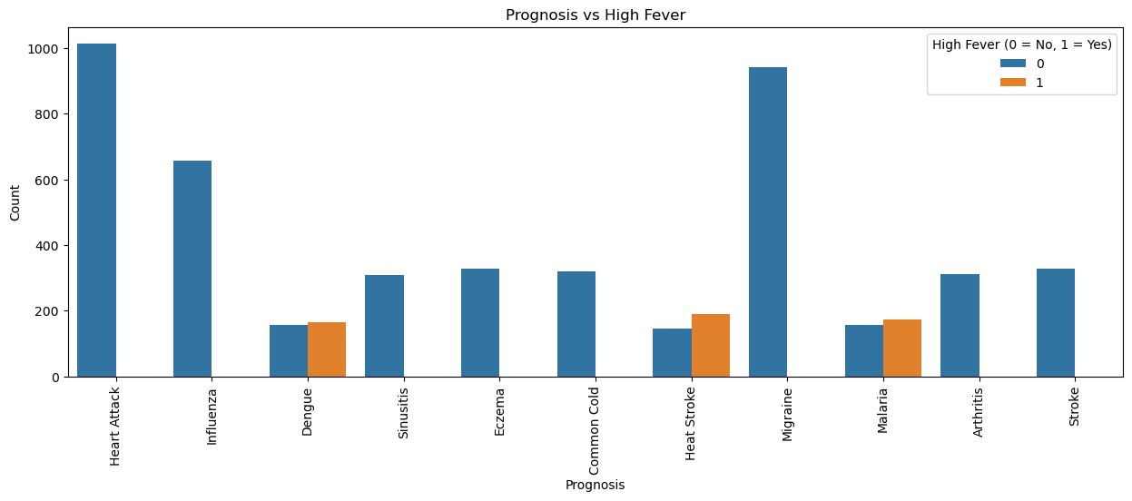
#MULTIVARIATE ANALYSIS
#Principal component analysis
from sklearn import datasets, decomposition
iris = datasets.load_iris()
X = iris.data
y = iris.target
pca = decomposition.PCA(n_components=2)
X = pca.fit_transform(X)
sns.scatterplot(x=X[:, 0], y=X[:, 1], hue=y)
<Axes: >
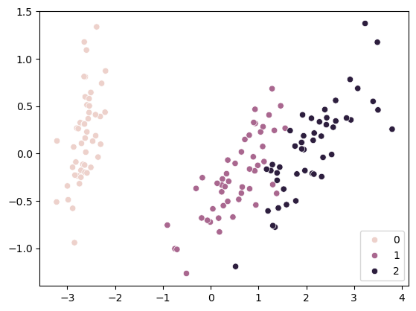
import seaborn as sns
import matplotlib.pyplot as plt
import numpy as np
# Select only numeric columns for correlation
numeric_data = data.select_dtypes(include=['int64', 'float64'])
# Compute correlation
corr_matrix = numeric_data.corr()
# Plot square heatmap
plt.figure(figsize=(10, 10))
sns.heatmap(corr_matrix, annot=True, cmap='coolwarm', fmt=".2f", square=True, linewidths=0.5)
plt.title('Square Correlation Heatmap (Numeric Features Only)')
plt.show()
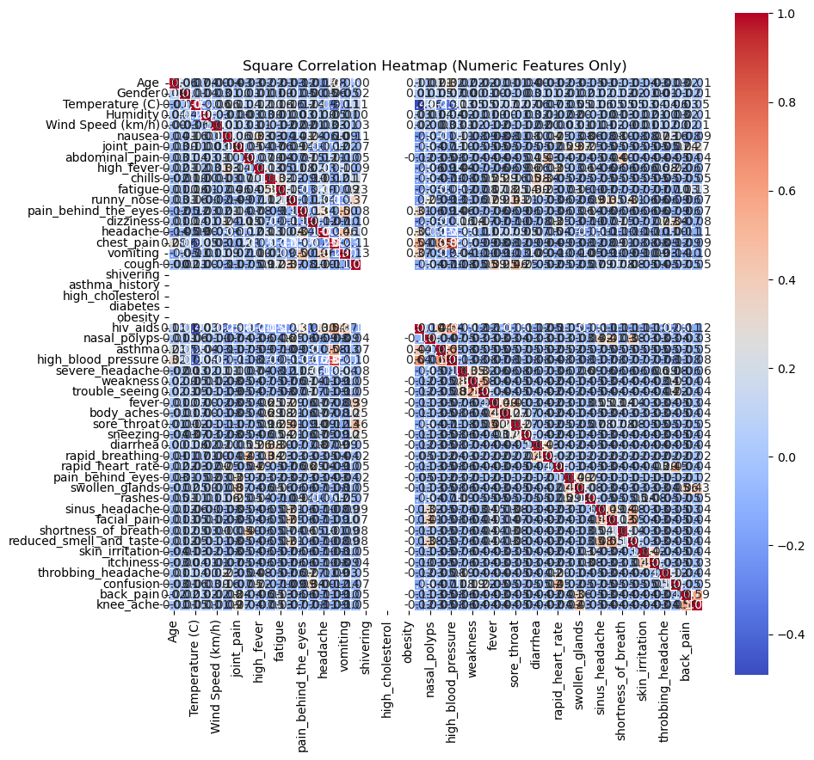

Conclusion

After studying the dataset and performing data analysis, we found that weather conditions do have a strong connection with the spread of certain diseases. For example, high humidity and rainy weather often lead to more cases of diseases like malaria and dengue. In colder weather, there are more chances of flu and respiratory infections.
By using data analysis and machine learning, we were able to create a model that can predict the chances of disease outbreaks based on weather conditions. This kind of prediction system can be very helpful for hospitals, doctors, and local health authorities. It allows them to prepare in advance and take steps to stop the disease from spreading.
In simple words, this project shows that by using weather data and technology, we can protect people's health and possibly save lives. It also proves that data science can be a powerful tool in solving real-life health problems.

Github Link:

